Project structure

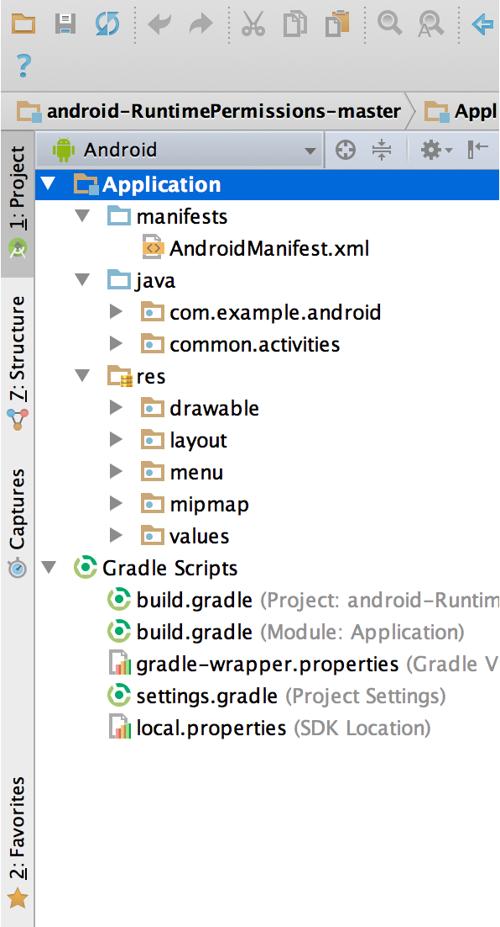

**Figure 1.** The project files in Android view.

Each project in Android Studio contains one or more modules with source code files and resource files. Types of modules include:

* Android app modules
* Library modules
* Google App Engine modules

By default, Android Studio displays your project files in the Android project view, as shown in figure 1. This view is organized by modules to provide quick access to your project's key source files.

All the build files are visible at the top level under **Gradle Scripts** and each app module contains the following folders:

* **manifests**: Contains the AndroidManifest.xml file.
* **java**: Contains the Java source code files, including JUnit test code.
* **res**: Contains all non-code resources, such as XML layouts, UI strings, and bitmap images.

The Android project structure on disk differs from this flattened representation. To see the actual file structure of the project, select **Project** from the **Project** dropdown (in figure 1, it's showing as **Android**).

You can also customize the view of the project files to focus on specific aspects of your app development. For example, selecting the **Problems** view of your project displays links to the source files containing any recognized coding and syntax errors, such as a missing XML element closing tag in a layout file.

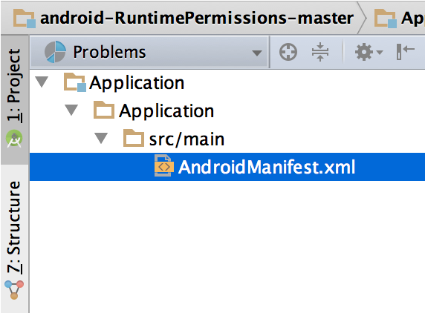

**Figure 2.** The project files in Problems view, showing a layout file with a problem.

# Android Architecture

**android architecture** or **Android software stack** is categorized into five parts:

1. linux kernel
2. native libraries (middleware),
3. Android Runtime
4. Application Framework
5. Applications

Let's see the android architecture first.

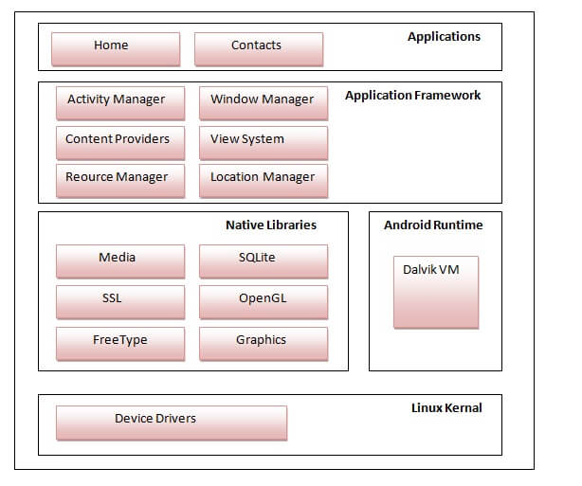

## **Android Versions, Codename and API**

Let's see the android versions, codenames and API Level provided by Google.

